首先明确，jni的作用是即使是在java的编程环境下，也可以用c来进行编程。Jni就是通道，通过它，把java转成c

- 先要在eclipse的“preferences”，点击“Android”下“NDK”，在右边的弹出框中“NDK Location”选上下载安装的NDK地址。
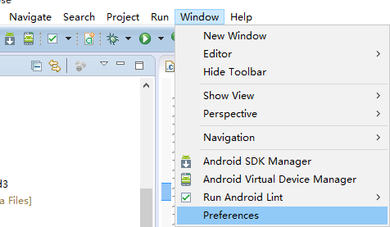
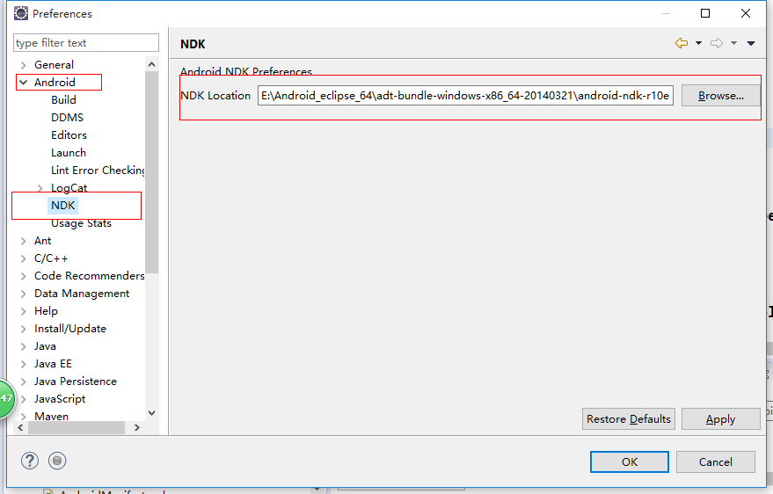
2.关联NDK源代码。

2.建一个普通的安卓工程。为它添加一个叫“jni”的文件夹。并在文件夹下建立两个文件：Android.mk和你的c源程序（这里是led3.c）。
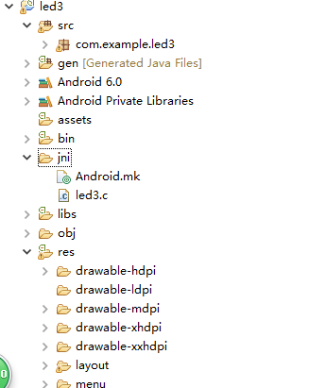
（当然，也可以直接项目右键“Android Tools”，“Add Native Support”，它会自动生成Android.mk和你的c源程序）

3.在安卓源码中写上会用到的c方法（这里的方法有openled(),closeled(),ioctl()等，它们的实现，是c语言）
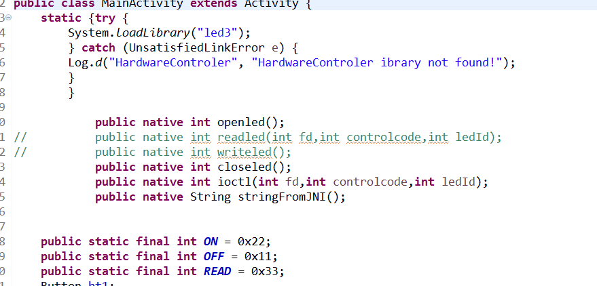
- c方法的实现，
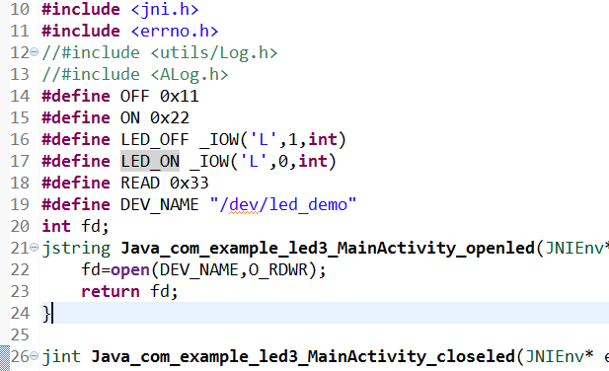（下是全源码，这里其实是去访问“/dev/下的设备文件”。Open/close/ioctl都是驱动实现的方法）
#include <stdio.h>
#include <stdlib.h>
#include <termios.h>
#include <unistd.h>
#include <sys/types.h>
#include <sys/stat.h>
#include <sys/ioctl.h>
#include <fcntl.h>
#include <string.h>
#include <jni.h>
#include <errno.h>
//#include <utils/Log.h>
//#include <ALog.h>
#define OFF 0x11
#define ON 0x22
#define LED_OFF _IOW('L',1,int)
#define LED_ON _IOW('L',0,int)
#define READ 0x33
#define DEV_NAME "/dev/led_demo"
int fd;
jstring Java_com_example_led3_MainActivity_openled(JNIEnv* env, jobject obj){
//jni的jstring对应java的String，连通的是c的char*。
//Java_com_example_led3_MainActivity_openled(JNIEnv* env, jobject obj)：java_包名_类名_方法名(JNIEnv* env, jobject obj)
//JNIEnv* env, jobject obj是必须的。
fd=open(DEV_NAME,O_RDWR);
return fd;
}

jint Java_com_example_led3_MainActivity_closeled(JNIEnv* env, jobject obj){
int ret;
ret = close(fd);
return ret;
}

jint Java_com_example_led3_MainActivity_ioctl(JNIEnv* env, jobject obj,jint fd,jint controlcode,jint ledid){
int CTLCODE = controlcode;
int value =-1;
switch(CTLCODE)
{ case ON:
{
ioctl(fd,LED_ON,ledid);//setLedState( 0, 1 );//调用驱动程序中的ioctrl接口，把命令传下去，实现硬件操作
break;
}
case OFF:
{
ioctl(fd,LED_OFF,ledid);//// setLedState( 0, 0 );//调用驱动程序中的ioctrl接口，把命令传下去，实现硬件操作
break;
}
case READ:
{
value=ioctl(fd,3,ledid);// 2 表示读取状态的cmd；0、1表示led控制的命令；
return value;
break;
}
default:break;
}
return 0;
}

jint Java_com_example_led3_MainActivity_stringFromJNI(JNIEnv* env, jobject obj){
return (*env)->NewStringUTF(env, "Hello from JNI !");
}

补充：以下是linux驱动
led_demo.h
#ifndef __LED_DEMO_H__
#define __LED_DEMO_H__
#include <linux/cdev.h>
#define LED_ON _IOW('L', 0, int)
#define LED_OFF _IOW('L', 1, int)
#define LED_DEMO_DEVICE_NODE_NAME "led_demo"
#define LED_DEMO_DEVICE_CLASS_NAME "led_demo"
#define LED_DEMO_DEVICE_FILE_NAME "led_demo"
#define EXYNOS4412_GPM4CON 0x110002E0
#define EXYNOS4412_GPM4DAT 0x110002E4

struct led_demo_dev
{
struct cdev dev;
};
#endif

Led_demo.c
#include <linux/kernel.h>
#include <linux/module.h>
#include <linux/fs.h>
#include <linux/slab.h>
#include <linux/device.h>
#include <asm/io.h>
#include <asm/uaccess.h>
#include "led_demo.h"

MODULE_LICENSE("GPL");

static int led_demo_major;
static int led_demo_minor;
static int number_of_dev = 1;
static struct led_demo_dev *led_dev = NULL;
static unsigned int *GPM4CON = NULL;
static unsigned int *GPM4DAT = NULL;
static struct class *led_demo_class = NULL;

static int led_open (struct inode *node, struct file *fops)
{
struct led_demo_dev *dev;
dev = container_of(node->i_cdev, struct led_demo_dev, dev);
fops->private_data = dev;
return 0;
}
static int led_close (struct inode *node, struct file *fops)
{
return 0;
}

static long led_ioctl (struct file *fops, unsigned int cmd, unsigned long data)
{
//struct led_demo_dev * led_dev = (struct led_demo_dev *)fops->private_data;

if((data < 1) || (data > 4))
{
printk(KERN_ALERT"parameter is no valid.\n");
return -EINVAL;
}

switch (cmd)
{
case LED_OFF:
writel(readl(GPM4DAT) | (0x1<<(data-1)), GPM4DAT);
break;
case LED_ON:
writel(readl(GPM4DAT) & ~(0x1<<(data-1)), GPM4DAT);
break;
default:
return -EINVAL;
break;
}
return 0;
}

struct file_operations led_fops =
{
.owner = THIS_MODULE,
.open = led_open,
.unlocked_ioctl = led_ioctl,
.compat_ioctl = led_ioctl,
.release = led_close,
};

static int __led_setup_dev(struct led_demo_dev * dev)
{
int err = -1;
dev_t devno = MKDEV(led_demo_major, led_demo_minor);
memset(dev, 0, sizeof(struct led_demo_dev));
cdev_init(&(dev->dev), &led_fops);
dev->dev.owner = THIS_MODULE;
err = cdev_add(&(dev->dev), devno, number_of_dev);
if(err < 0)
{
return err;
}
return 0;
}

static int led_demo_init(void)
{
int err = -1;
dev_t dev;
struct device *temp = NULL;
printk(KERN_ALERT"Initializing led demo device.\n");
err = alloc_chrdev_region(&dev, 0, number_of_dev, LED_DEMO_DEVICE_NODE_NAME);
if(err < 0)
{
printk(KERN_ALERT"fail to alloc char dev region.\n");
goto fail;
}

led_demo_major = MAJOR(dev);
led_demo_minor = MINOR(dev);

led_dev = kmalloc(sizeof(struct led_demo_dev), GFP_KERNEL);
if(!led_dev)
{
err = -ENOMEM;
printk(KERN_ALERT"Failed to alloc led device.\n");
goto unregister;
}

err = __led_setup_dev(led_dev);
if (err < 0)
{
printk(KERN_ALERT"Failed to setup led device.\n");
goto clean_up;
}

GPM4CON = (unsigned int *)ioremap(EXYNOS4412_GPM4CON, 4);
if(!GPM4CON)
{
err = -ENOMEM;
goto destroy_cdev;
}

GPM4DAT = (unsigned int *)ioremap(EXYNOS4412_GPM4DAT, 4);
if(!GPM4DAT)
{
err = -ENOMEM;
goto unmap1;
}

writel((readl(GPM4CON) & ~0xffff) | 0x1111, GPM4CON);
writel(readl(GPM4DAT)| 0xf, GPM4DAT);

led_demo_class = class_create(THIS_MODULE, LED_DEMO_DEVICE_CLASS_NAME);
if(IS_ERR(led_demo_class))
{
err = PTR_ERR(led_demo_class);
printk(KERN_ALERT"Failed to create led demo class.\n");
goto unmap2;
}

temp=device_create(led_demo_class,NULL,dev,NULL,"%s", LED_DEMO_DEVICE_FILE_NAME);
if(IS_ERR(temp))
{
err = PTR_ERR(temp);
printk(KERN_ALERT"Failed to create led demo device.\n");
goto destroy_class;
}
dev_set_drvdata(temp, (void *)led_dev);
printk(KERN_ALERT"Succeed to initialize led demo device.\n");
return 0;

destroy_class:
class_destroy(led_demo_class);

unmap2:
iounmap(GPM4DAT);

unmap1:
iounmap(GPM4CON);

destroy_cdev:
cdev_del(&(led_dev->dev));

clean_up:
kfree(led_dev);

unregister:
unregister_chrdev_region(MKDEV(led_demo_major, led_demo_minor), number_of_dev);

fail:
return err;
}
static void led_demo_exit(void)
{
if(led_demo_class)
{
device_destroy(led_demo_class, MKDEV(led_demo_major, led_demo_minor));
class_destroy(led_demo_class);
}
iounmap(GPM4DAT);
iounmap(GPM4CON);
if(led_dev)
{
cdev_del(&(led_dev->dev));
kfree(led_dev);
}
unregister_chrdev_region(MKDEV(led_demo_major, led_demo_minor), number_of_dev);
}

module_init(led_demo_init);
module_exit(led_demo_exit);

补充2：为了方便移植，我们可以单独建一个类来包含native方法和system.loadlibrary.
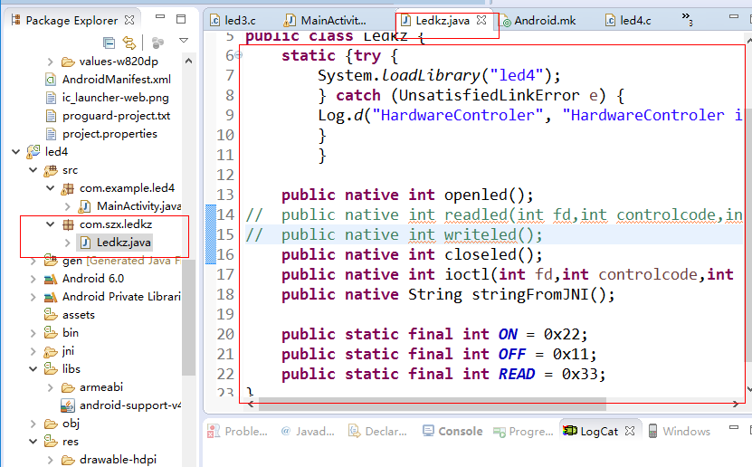
然后实现jni下的c源码。稍微有点区别的是，这时候的c方法名变成了
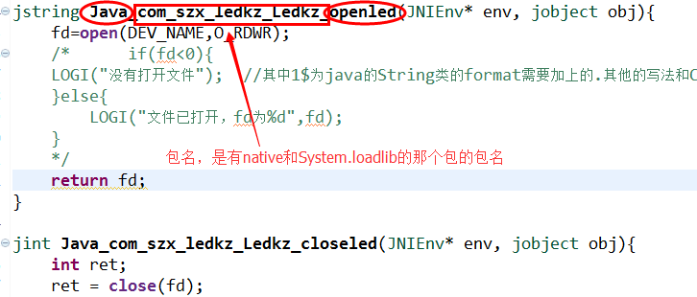
确保无错后，编译生成.so文件。新建另一个工程“led5”。把生成的这个.so文件和刚才的“com.szx.ledkz”都复制到新工程中。
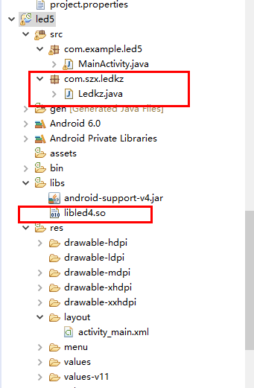
这样就可以让其他工程利用这个.so文件

注意：
当你的报名或类名中有”_”时，在jni的源程序中要写成“_1”
